**PIZZA Sales Report**

**A.KPI’s**

**DAX Queries:**

Total Revenue = Sum(pizza_sales_csv_file[total_price])

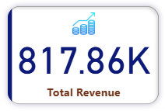

Total Pizza Sold = sum(pizza_sales_csv_file[quantity])

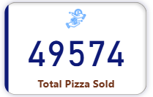

Total Orders = DISTINCTCOUNT(pizza_sales_csv_file[order_id])

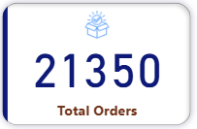

Average Orders Value = DIVIDE([Total Revenue],[Total Orders],0)

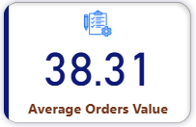

Avg_Pizzas_Per_Order = [Total Pizza Sold]/[Total Orders]

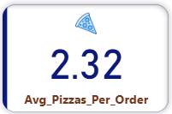

**B. Charts:**

**1. a. Daily Trend for Total Orders:**  
Bar chart that displays the daily trend of total orders over a specific time period. This chart will help us identify any patterns or fluctuations in order volumes on a daily basis.

**--Weekday-wise**

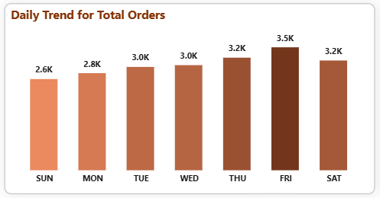

**--Month-wise**

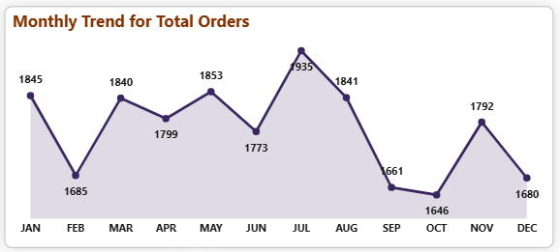

**b. Hourly Trend for Total Orders:**  
Chart that illustrates the hourly trend of total orders throughout the day. This chart will allow us to identify peak hours or periods of high order activity.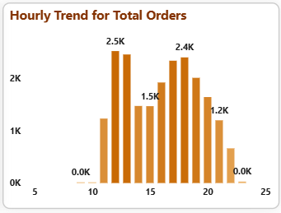

**2. Percentage of Sales by Pizza Category:**  
A pie chart that shows the distribution of sales across different pizza categories. This chart will provide insights into the popularity of various pizza categories and their contribution to overall sales

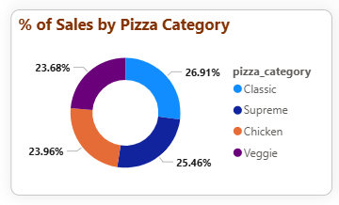

**3. Percentage of Sales by Pizza Size:**

**A pie chart that represents the percentage of sales attributed to different pizza sizes. This chart will help us understand customer preferences for pizza sizes and their impact on sales.**

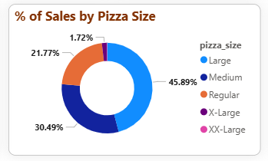

**4. Total Pizzas Sold by Pizza Category:**

**A funnel chart that presents the total number of pizzas sold for each pizza category. This chart will allow us to compare the sales performance of different pizza categories.**

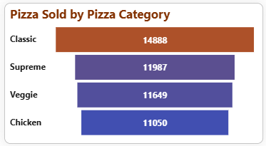

**5. Top 5 Best Sellers by Total Pizzas Sold:**

**A bar chart highlighting the top 5 best-selling pizzas based on the total number of pizzas sold. This chart will help us identify the most popular pizza options.**

--Top 5 by total Revenue

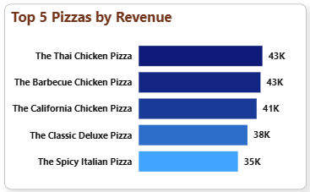

--Top 5 by Total quantity of pizzas sold

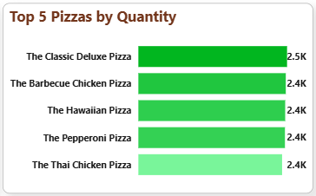

--Top 5 by Total_orders

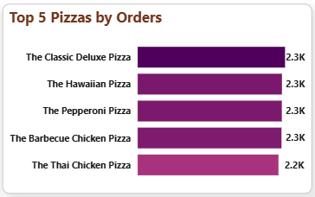

**C. Insights Derived**

